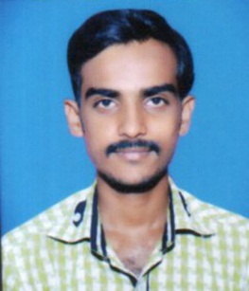

**Akshay Ashok Debadwar**

Padmavati Galli , Parli Vaijanath Pin-431515

Dist.: Beed

**Contact no.:** +91-8605699033

**Email ID:** debadwarakshay@gmail.com

**Career Objective**:

To work for an organization which provides me the opportunity to improve my skills and knowledge to growth along with the organization objective.

**Educational Qualifications:**

* **Education:** Bachelor of Computer Application (Pursuing).
* **Institute: Yogeshwari Mahavidyalaya , Ambajogai**.

|  |  |  |  |  |  |  |  |
| --- | --- | --- | --- | --- | --- | --- | --- |
| Semester | I | II | III | IV | V | VI | CGPA |
| SGPA | **8.10** | **7.68** | **6.94** | **7.64** | **7.57** | **7.82** | **7.00** |

**Semester Performance: CGPA-: 7.00**

|  |  |  |  |
| --- | --- | --- | --- |
| Class | Year Of Passing | Board | Percentage |
| HSC | **2013** | **Aurangabad Board** | **49.60%** |
| SSC | **2011** | **Aurangabad Board** | **49.45%** |

**Projects:**

1. **College Getpass Management System.**
2. **Institute Management System.**

**Skills Set:**

**Programming Language: C**

**Software used : VB.Net 2010.**

**Working Platforms : Windows , MS-DOS**

**Achievements:**

* Got 1st Prize in Graduation Agreegrate In my caste.
* Got 2nd Prize in No backlog in three year.

**Extra-Curricular Activities:**

* Participated in social work management.
* Participation in seminar prasentation.

**Personal Details:**

**Father’s Name:** Mr. Ashok Pandharinath Debadwar

**Mother’s Name:** Mrs. Sunita Ashok Debadwar

**Date of Birth:** 26th July 1996

**Languages Known:** Hindi And Marathi.

**Hobbies :**

* Travelling
* Tracking
* New Things Any Filds
* Listening to music

**Declaration :**

I, undersigned hereby declare that the above given information is true to the best of my knowledge.

**Place: Parli Vaijanath**

**Date: Akshay Ashok Debadwar**